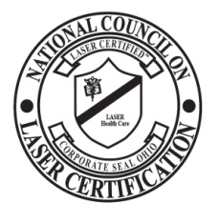
NCLC Proctor Evaluation and Report
To be returned with the exam. (or emailed by Proctor if online exam)

Your name ____________________________ Date _________ Testing Location __________________

Proctor Name _____________________________

This evaluation is intended only to monitor the consistency, impartiality, and security of the NCLC examination process. If your proctor was separately involved with training of any type, this evaluation has nothing to do with their effectiveness as a trainer. It is simply to ensure compliance with examination security policies of the NCLC.

1. Did the Proctor read the rules of the examination to you prior to starting the test? Y N

2. Did the Proctor start the exam at the same time for all? and did they ensure that no one took longer than allowed - to the best of your observation? Y N

3. Did the Proctor show impartiality to all examinees, by giving no sign of assisting anyone with answers to questions or coaching them on any question? Y N
(an exception to this would be to better clarify a question if English is not their primary language)

4. Did the proctor appear to properly monitor the examination for all to preclude cheating including the use of reference materials, phone use or talking among examinees? Y N

5. How would you rate the fairness and effectiveness of your Proctor in administering this exam?
1 is lowest and 5 is highest. 3 is neutral
1 2 3 4 5

6. Were the testing facilities adequate to support the examination? i.e. lighting, noise, temperature, etc.
Y N
7. Other comments or explanations below:

V230613

